Coaxial Composite Solids

Definition
# Source: AI Source: Provided by: [Data Path: Persons Table -> ID Column: 1, Name_En Column: Motasem Essam] -> From: [ChatGPT] on [7/25/2026]
Coaxial Composite Solids are composite three-dimensional objects formed by joining or arranging two or more solid components so that their central axes lie along the same straight line.
The components share a common axis, called the coaxial axis. They may have identical or different shapes, dimensions, and positions along this axis.
Coaxial arrangements commonly involve cylinders, cones, spheres, hemispheres, and other solids with identifiable central axes.
Simple Definition: Coaxial composite solids are made by combining two or more solids that share the same central axis.

Geometric Representation
# Source: AI Source: Provided by: [Data Path: Persons Table -> ID Column: 1, Name_En Column: Motasem Essam] -> From: [ChatGPT] on [7/25/2026]
A coaxial composite solid has components aligned around or along one common axis.
Typical examples include:
- Two cylinders of different radii joined end-to-end.
- A cone attached to a cylinder through a common circular base.
- A hemisphere joined to a cylinder along their circular bases.
- Several cylindrical sections arranged along one central axis.
- A sphere positioned centrally along the axis of a cylindrical component.
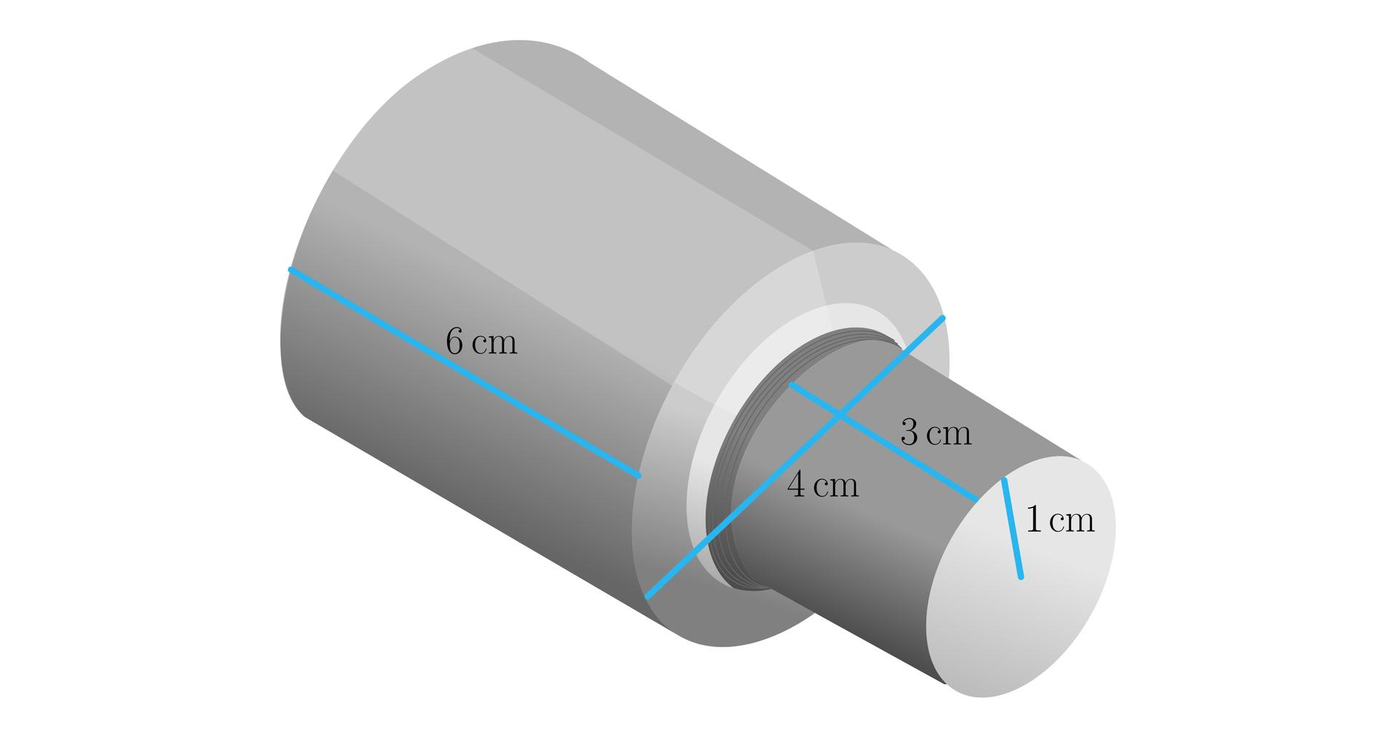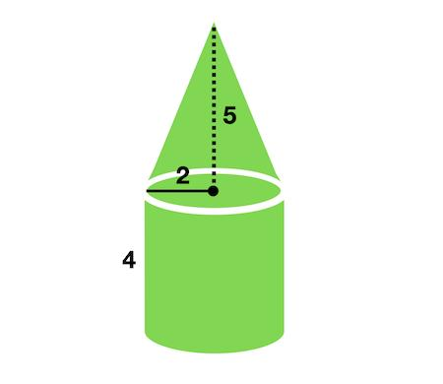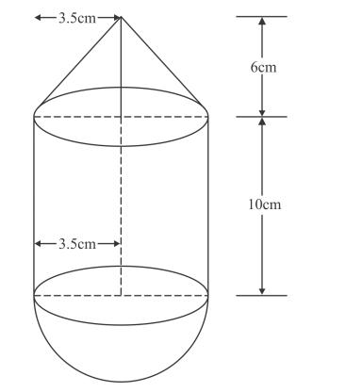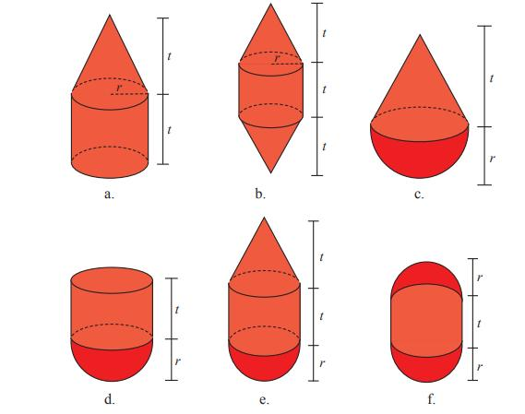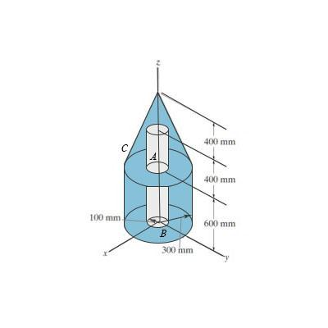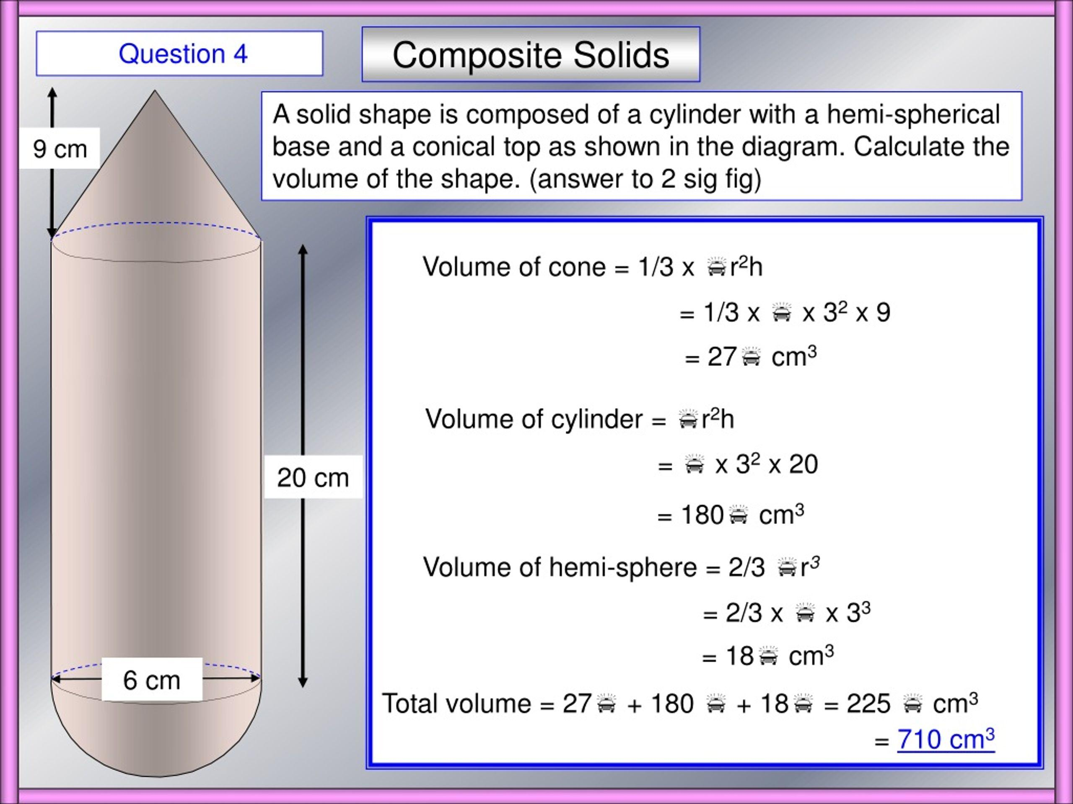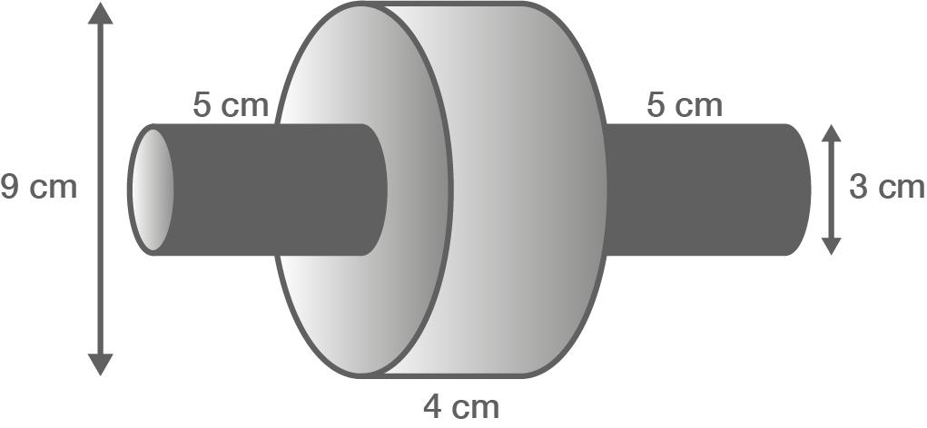

Main Classification

Types of Coaxial Composite Solids
# Source: AI Source: Provided by: [Data Path: Persons Table -> ID Column: 1, Name_En Column: Motasem Essam] -> From: [ChatGPT] on [7/25/2026]

Cylinder-Based Coaxial Composite Solids
# Source: AI Source: Provided by: [Data Path: Persons Table -> ID Column: 1, Name_En Column: Motasem Essam] -> From: [ChatGPT] on [7/25/2026]
Formed by combining two or more cylinders that share the same central axis.
Examples include:
- Equal-radius coaxial cylinders.
- Different-radius coaxial cylinders.
- Stepped coaxial cylinders.
- Hollow coaxial cylinder assemblies.

Cone-Based Coaxial Composite Solids
# Source: AI Source: Provided by: [Data Path: Persons Table -> ID Column: 1, Name_En Column: Motasem Essam] -> From: [ChatGPT] on [7/25/2026]
Formed by combining two or more cones that share a common axis.
Examples include:
- Two cones joined base-to-base.
- Two cones joined apex-to-base.
- Multiple coaxial cones.
- Cone and conical-frustum combinations.
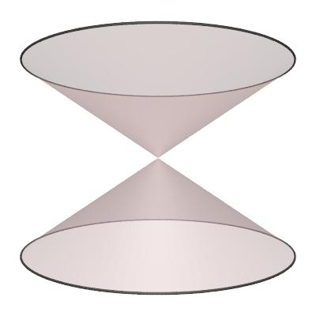

Prism-Based Coaxial Composite Solids
# Source: AI Source: Provided by: [Data Path: Persons Table -> ID Column: 1, Name_En Column: Motasem Essam] -> From: [ChatGPT] on [7/25/2026]
Formed by combining solids with prism components arranged around a common reference axis.
Examples include:
- Regular polygonal prisms with aligned central axes.
- Different-sized polygonal prisms arranged along the same axis.
- A prism combined with a coaxial cylinder where their axes coincide.
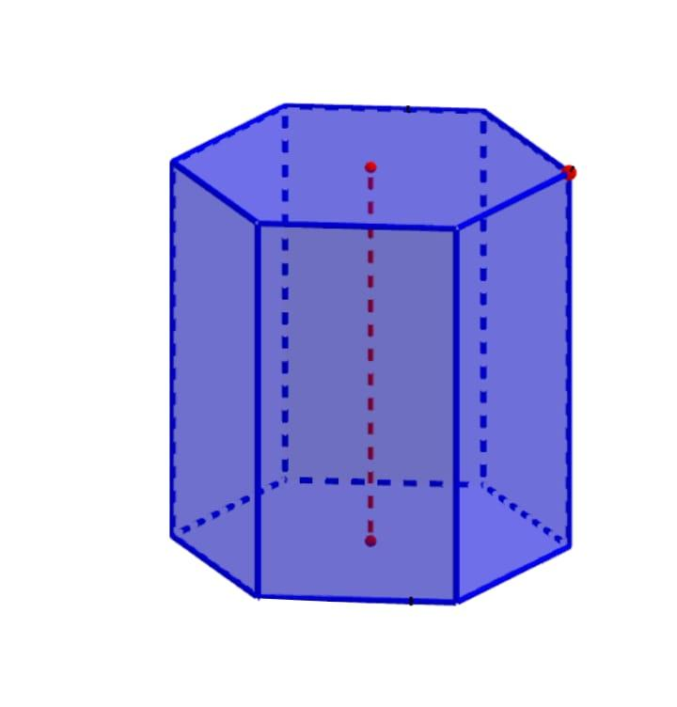

Pyramid-Based Coaxial Composite Solids
# Source: AI Source: Provided by: [Data Path: Persons Table -> ID Column: 1, Name_En Column: Motasem Essam] -> From: [ChatGPT] on [7/25/2026]
Formed by combining pyramidal components whose central or symmetry axes lie along the same straight line.
Examples include:
- Two regular pyramids joined base-to-base.
- A pyramid attached to a prism along a common axis.
- Multiple symmetrical pyramids arranged coaxially.
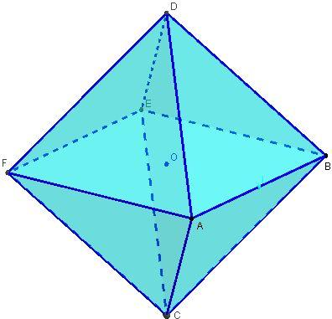

Sphere-Based Coaxial Composite Solids
# Source: AI Source: Provided by: [Data Path: Persons Table -> ID Column: 1, Name_En Column: Motasem Essam] -> From: [ChatGPT] on [7/25/2026]
Formed by combining spheres or spherical components whose centers lie on the same straight axis.
Examples include:
- Two spheres with centers along a common axis.
- Concentric spheres with a shared center.
- A sphere combined with a coaxial cylinder.
- Multiple spherical components arranged along one axis.
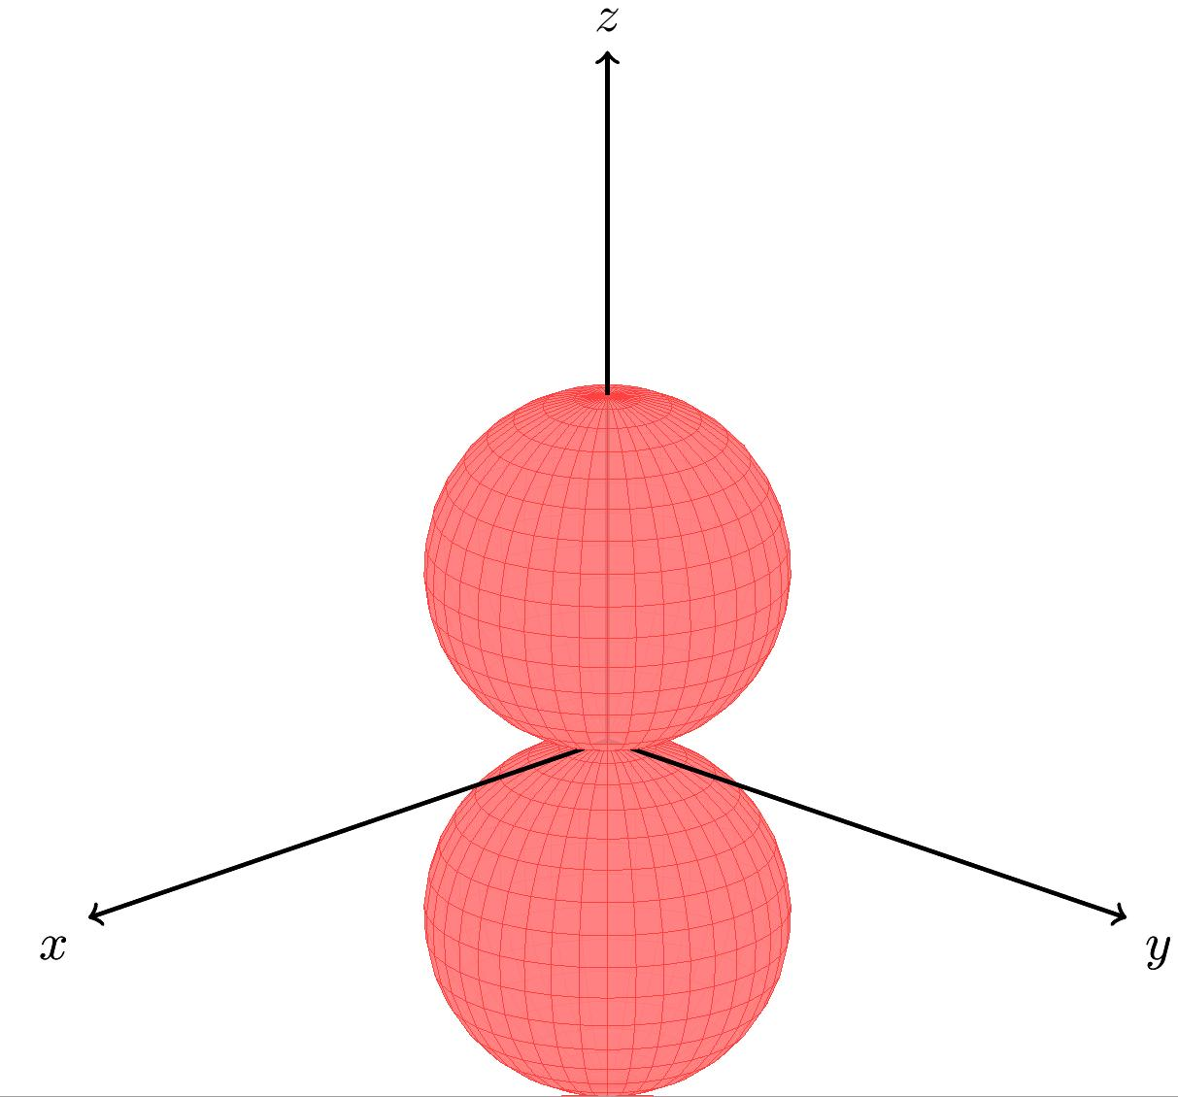

Hemisphere-Based Coaxial Composite Solids
# Source: AI Source: Provided by: [Data Path: Persons Table -> ID Column: 1, Name_En Column: Motasem Essam] -> From: [ChatGPT] on [7/25/2026]
Formed by combining hemispheres with their symmetry axes aligned along the same straight line.
Examples include:
- Two hemispheres joined base-to-base.
- A hemisphere attached to a cylinder.
- Hemispheres attached to opposite ends of a cylindrical component.
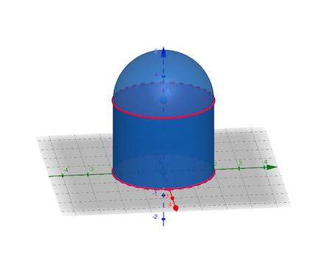

Mixed-Shape Coaxial Composite Solids
# Source: AI Source: Provided by: [Data Path: Persons Table -> ID Column: 1, Name_En Column: Motasem Essam] -> From: [ChatGPT] on [7/25/2026]
Formed by combining different types of solids that share a common axis.
Examples include:
- Cylinder and cone.
- Hemisphere and cylinder.
- Sphere and cylinder.
- Cylinder, cone, and hemisphere.
- Prism, cylinder, and cone with aligned axes.

Classification by Component Arrangement
# Source: AI Source: Provided by: [Data Path: Persons Table -> ID Column: 1, Name_En Column: Motasem Essam] -> From: [ChatGPT] on [7/25/2026]
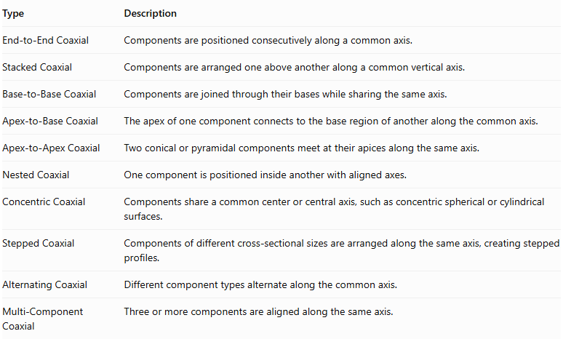
Type | Description
End-to-End Coaxial | Components are positioned consecutively along a common axis.
Stacked Coaxial | Components are arranged one above another along a common vertical axis.
Base-to-Base Coaxial | Components are joined through their bases while sharing the same axis.
Apex-to-Base Coaxial | The apex of one component connects to the base region of another along the common axis.
Apex-to-Apex Coaxial | Two conical or pyramidal components meet at their apices along the same axis.
Nested Coaxial | One component is positioned inside another with aligned axes.
Concentric Coaxial | Components share a common center or central axis, such as concentric spherical or cylindrical surfaces.
Stepped Coaxial | Components of different cross-sectional sizes are arranged along the same axis, creating stepped profiles.
Alternating Coaxial | Different component types alternate along the common axis.
Multi-Component Coaxial | Three or more components are aligned along the same axis.
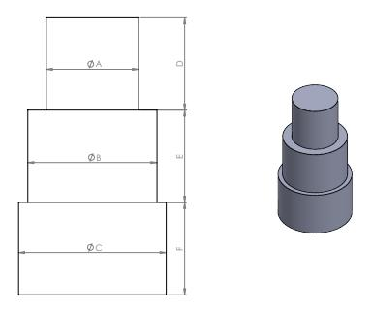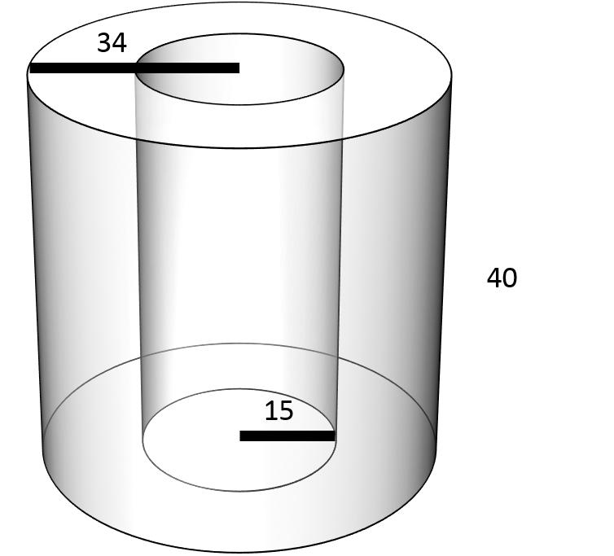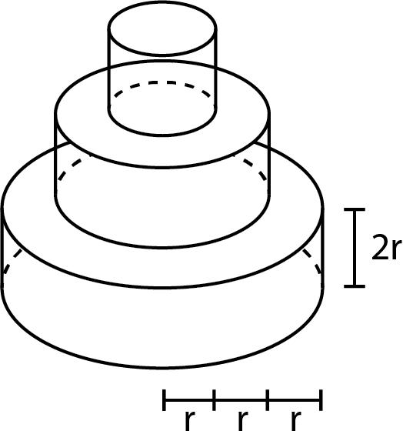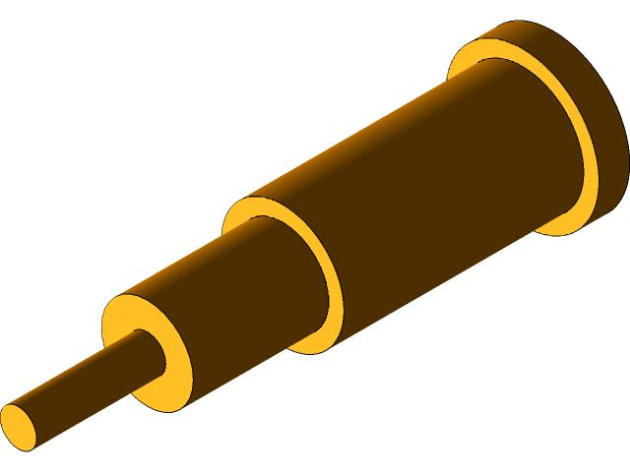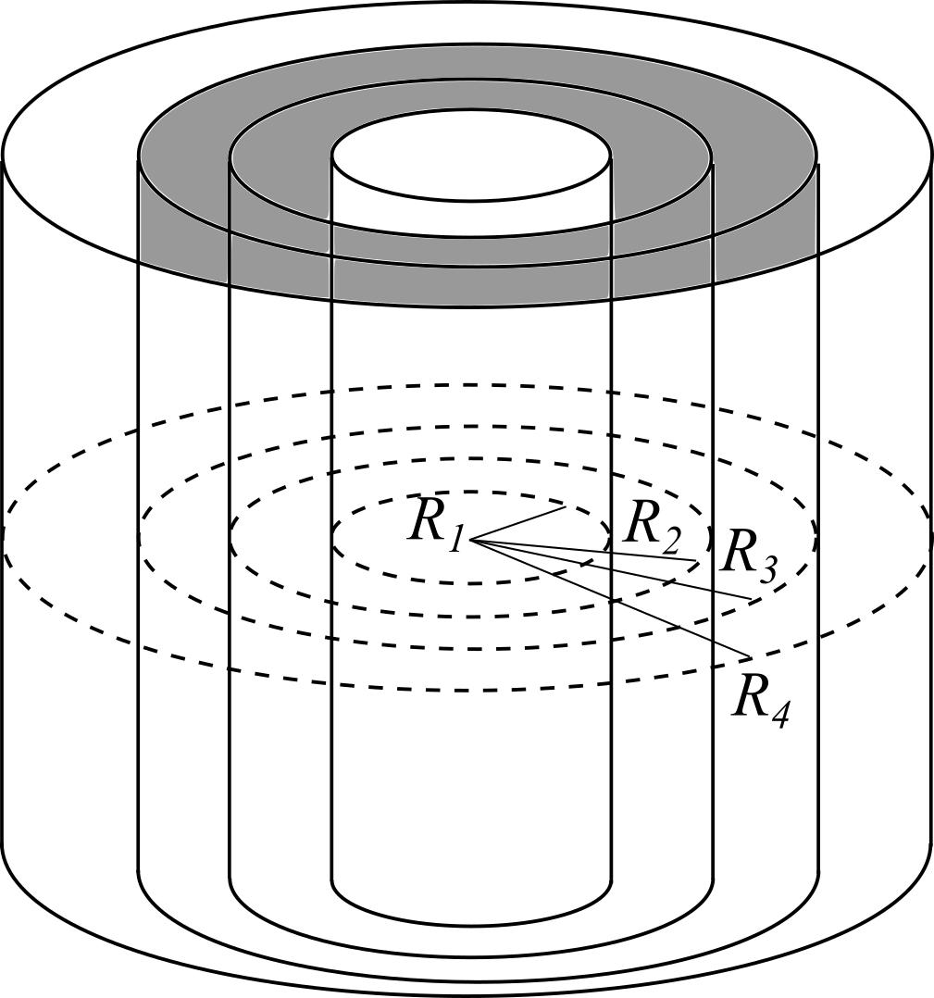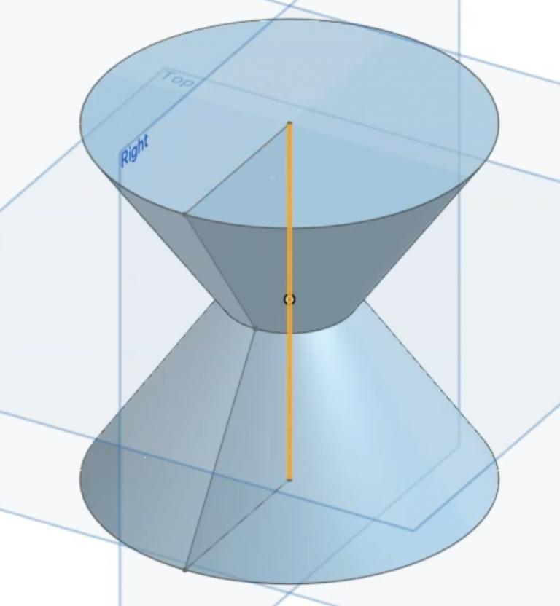

Classification by Axis Orientation
# Source: AI Source: Provided by: [Data Path: Persons Table -> ID Column: 1, Name_En Column: Motasem Essam] -> From: [ChatGPT] on [7/25/2026]
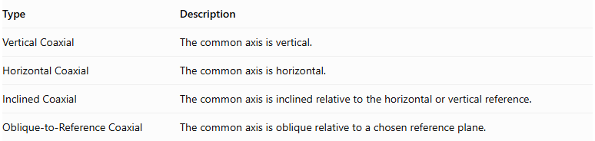
Type | Description
Vertical Coaxial | The common axis is vertical.
Horizontal Coaxial | The common axis is horizontal.
Inclined Coaxial | The common axis is inclined relative to the horizontal or vertical reference.
Oblique-to-Reference Coaxial | The common axis is oblique relative to a chosen reference plane.
Important: Coaxial describes the relationship between component axes, not their orientation relative to the ground. Two solids can be coaxial even when their common axis is horizontal, vertical, or inclined.

Classification by Cross-Sectional Dimensions
# Source: AI Source: Provided by: [Data Path: Persons Table -> ID Column: 1, Name_En Column: Motasem Essam] -> From: [ChatGPT] on [7/25/2026]
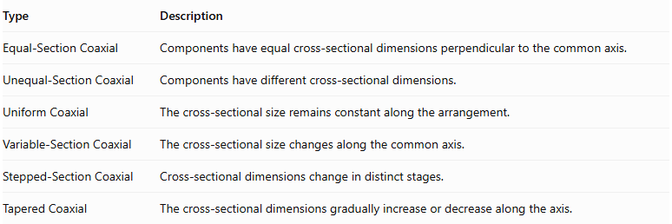
Type | Description
Equal-Section Coaxial | Components have equal cross-sectional dimensions perpendicular to the common axis.
Unequal-Section Coaxial | Components have different cross-sectional dimensions.
Uniform Coaxial | The cross-sectional size remains constant along the arrangement.
Variable-Section Coaxial | The cross-sectional size changes along the common axis.
Stepped-Section Coaxial | Cross-sectional dimensions change in distinct stages.
Tapered Coaxial | The cross-sectional dimensions gradually increase or decrease along the axis.

Mathematical Properties and Formulas
# Source: AI Source: Provided by: [Data Path: Persons Table -> ID Column: 1, Name_En Column: Motasem Essam] -> From: [ChatGPT] on [7/25/2026]
The calculations depend on the component shapes, their dimensions, and whether their interiors overlap.

Common Axis
# Source: AI Source: Provided by: [Data Path: Persons Table -> ID Column: 1, Name_En Column: Motasem Essam] -> From: [ChatGPT] on [7/25/2026]
For coaxial components, their central axes must lie on the same straight line.
If the common axis is represented by a line $L$, then:
$$L_{1}=L_{2}=⋯=L_{n}=L$$
This means that every component has the same central axis.

Volume
# Source: AI Source: Provided by: [Data Path: Persons Table -> ID Column: 1, Name_En Column: Motasem Essam] -> From: [ChatGPT] on [7/25/2026]
For components arranged without overlapping interiors:
$$V_{total}=V_{1}+V_{2}+⋯+V_{n}$$
For cylinders:
$$V=πr^{2}h$$
For cones:
$$V=\frac{1}{3}πr^{2}h$$
For spheres:
$$V=\frac{4}{3}πr^{3}$$
For hemispheres:
$$V=\frac{2}{3}πr^{3}$$
For mixed coaxial solids, calculate each component separately and add their volumes, correcting for any overlapping regions.

External Surface Area
# Source: AI Source: Provided by: [Data Path: Persons Table -> ID Column: 1, Name_En Column: Motasem Essam] -> From: [ChatGPT] on [7/25/2026]
The external surface area includes only the surfaces visible from outside the composite solid.
For two coaxial cylinders joined through complete matching circular bases of equal radius:
$${SA}_{total}={SA}_{1}+{SA}_{2}-2πr^{2}$$
For multiple equal-radius coaxial cylinders joined through $m$ complete circular interfaces:
$${SA}_{total}=\sum{{SA}_{i}}-2mπr^{2}$$
For different-radius components, only the actual shared contact area is hidden. Any uncovered annular or other exposed regions remain part of the external surface area.

Overall Axial Length
# Source: AI Source: Provided by: [Data Path: Persons Table -> ID Column: 1, Name_En Column: Motasem Essam] -> From: [ChatGPT] on [7/25/2026]
For components arranged consecutively along the common axis without overlap:
$$L_{total}=L_{1}+L_{2}+⋯+L_{n}$$
Where $L_{i}$ represents the axial length of each component.

Overall Height
# Source: AI Source: Provided by: [Data Path: Persons Table -> ID Column: 1, Name_En Column: Motasem Essam] -> From: [ChatGPT] on [7/25/2026]
For vertically arranged coaxial components:
$$H_{total}=H_{1}+H_{2}+⋯+H_{n}$$
This applies when the components are arranged consecutively without overlapping.

Worked Examples

Example 1: Two Coaxial Cylinders with Different Heights
# Source: AI Source: Provided by: [Data Path: Persons Table -> ID Column: 1, Name_En Column: Motasem Essam] -> From: [ChatGPT] on [7/25/2026]
Two cylinders are joined end-to-end through matching circular bases. They share the same central axis and have equal radii.
- Radius of both cylinders: $r=3$ cm
- Height of first cylinder: $h_{1}=4$ cm
- Height of second cylinder: $h_{2}=6$ cm
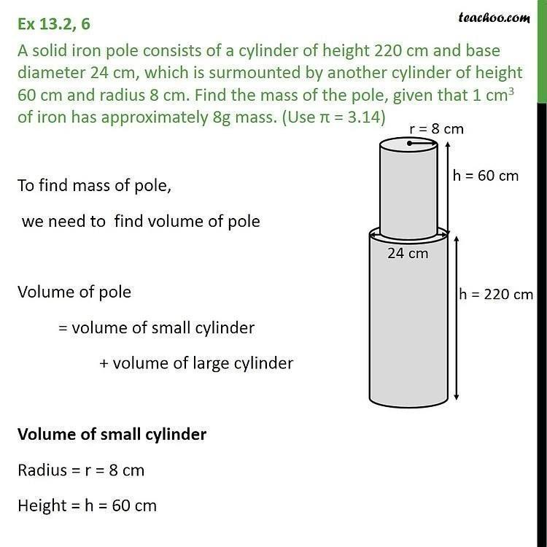
Step 1: Calculate the volume of the first cylinder.
$$V_{1}=πr^{2}h_{1}$$
$$V_{1}=π(3)^{2}(4)=36π$$
Step 2: Calculate the volume of the second cylinder.
$$V_{2}=πr^{2}h_{2}$$
$$V_{2}=π(3)^{2}(6)=54π$$
Step 3: Calculate the total volume.
$$V_{total}=36π+54π$$
$$\boxed{V_{total}=90π≈282.74{ cm}^{3}}$$
Step 4: Calculate the external surface area.
The two cylinders share one circular base:
$$A_{c}=πr^{2}=9π$$
The total surface area before joining is:
$${SA}_{1}=2πr^{2}+2π{rh}_{1}=42π$$
$${SA}_{2}=2πr^{2}+2π{rh}_{2}=54π$$
Subtract the two hidden circular faces:
$${SA}_{total}=42π+54π-2(9π)$$
$$\boxed{{SA}_{total}=78π≈245.04{ cm}^{2}}$$
Step 5: Calculate the total height.
$$H=4+6$$
$$\boxed{H=10 cm}$$

Example 2: A Hemisphere, Cylinder, and Cone Sharing One Axis
# Source: AI Source: Provided by: [Data Path: Persons Table -> ID Column: 1, Name_En Column: Motasem Essam] -> From: [ChatGPT] on [7/25/2026]
A hemisphere, cylinder, and cone are arranged consecutively along the same vertical axis. Their circular bases have equal radii and are connected through matching circular faces.
- Radius: $r=3$ cm
- Cylinder height: $h_{c}=6$ cm
- Cone height: $h_{k}=4$ cm
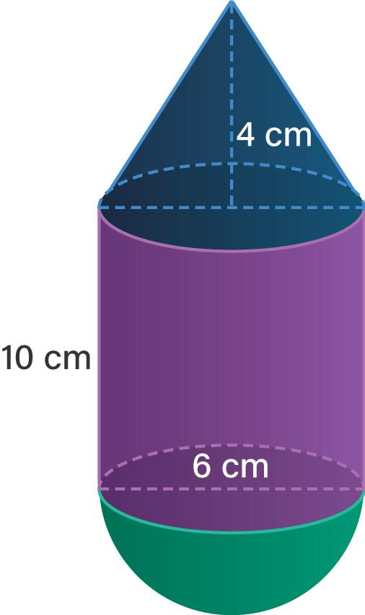
Step 1: Calculate the hemisphere volume.
$$V_{h}=\frac{2}{3}πr^{3}$$
$$V_{h}=\frac{2}{3}π(3)^{3}=18π$$
Step 2: Calculate the cylinder volume.
$$V_{c}=πr^{2}h_{c}$$
$$V_{c}=π(3)^{2}(6)=54π$$
Step 3: Calculate the cone volume.
$$V_{k}=\frac{1}{3}πr^{2}h_{k}$$
$$V_{k}=\frac{1}{3}π(3)^{2}(4)=12π$$
Step 4: Calculate the total volume.
$$V_{total}=18π+54π+12π$$
$$\boxed{V_{total}=84π≈263.89{ cm}^{3}}$$
Step 5: Calculate the external surface area.
The exposed surfaces are:
- Hemisphere curved surface: $2πr^{2}=18π$.
- Cylinder curved surface: $2πrh=36π$.
- Cone curved surface: $πrl$.
First calculate the cone slant height:
$$l=\sqrt{r^{2}+h_{k}^{2}}$$
$$l=\sqrt{3^{2}+4^{2}}=5$$
Therefore:
$${SA}_{k}=π(3)(5)=15π$$
Add the exposed surfaces:
$${SA}_{total}=18π+36π+15π$$
$$\boxed{{SA}_{total}=69π≈216.77{ cm}^{2}}$$
Step 6: Calculate the overall height.
$$H=3+6+4$$
The hemisphere contributes a height equal to its radius.
$$\boxed{H=13 cm}$$

Important Characteristics
# Source: AI Source: Provided by: [Data Path: Persons Table -> ID Column: 1, Name_En Column: Motasem Essam] -> From: [ChatGPT] on [7/25/2026]
- All components share one common central axis.
- Components may have equal or different cross-sectional dimensions.
- The common axis may be vertical, horizontal, or inclined.
- Components can be arranged end-to-end, stacked, nested, or base-to-base.
- Coaxial arrangements can contain identical or mixed solid types.
- Their volume is calculated by combining the component volumes, with overlap corrections when needed.
- Their external surface area excludes hidden contact regions.
- Their overall axial length is determined by the dimensions of the components along the common axis.
- Different component radii can create stepped or tapered external profiles.

Comparison with Other Composite Solid Arrangements
# Source: AI Source: Provided by: [Data Path: Persons Table -> ID Column: 1, Name_En Column: Motasem Essam] -> From: [ChatGPT] on [7/25/2026]
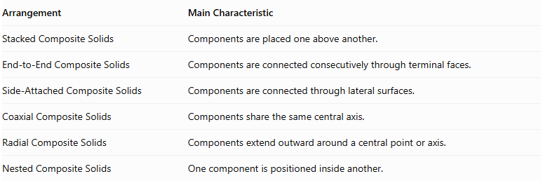
Arrangement | Main Characteristic
Stacked Composite Solids | Components are placed one above another.
End-to-End Composite Solids | Components are connected consecutively through terminal faces.
Side-Attached Composite Solids | Components are connected through lateral surfaces.
Coaxial Composite Solids | Components share the same central axis.
Radial Composite Solids | Components extend outward around a central point or axis.
Nested Composite Solids | One component is positioned inside another.
Important distinction: Coaxiality describes the alignment of axes. Stacking and end-to-end describe component arrangements. Therefore, a composite solid can be both coaxial and stacked, or both coaxial and end-to-end.

Applications
# Source: AI Source: Provided by: [Data Path: Persons Table -> ID Column: 1, Name_En Column: Motasem Essam] -> From: [ChatGPT] on [7/25/2026]
Coaxial composite solids are commonly found in:
- Stepped shafts and mechanical components.
- Cylindrical pipes and pipe connections.
- Rotating machine parts.
- Telescopic cylindrical assemblies.
- Conical and cylindrical industrial structures.
- Storage tanks with conical tops or bottoms.
- Optical and mechanical assemblies with aligned components.

Key Points
# Source: AI Source: Provided by: [Data Path: Persons Table -> ID Column: 1, Name_En Column: Motasem Essam] -> From: [ChatGPT] on [7/25/2026]
- Coaxial composite solids consist of two or more components sharing one straight central axis.
- Their components can be cylinders, cones, prisms, pyramids, spheres, hemispheres, or mixed shapes.
- Their common axis can have any spatial orientation.
- Their cross-sectional dimensions may remain constant or vary along the axis.
- Their volume is calculated by combining component volumes and correcting for overlaps.
- Their external surface area includes only exposed surfaces.
- Coaxiality is an axial relationship, not a specific joining method.

Conclusion
# Source: AI Source: Provided by: [Data Path: Persons Table -> ID Column: 1, Name_En Column: Motasem Essam] -> From: [ChatGPT] on [7/25/2026]
Coaxial Composite Solids are three-dimensional structures formed by combining two or more solid components whose central axes coincide along the same straight line. They may contain identical or different geometric shapes and can be arranged in stacked, end-to-end, base-to-base, nested, or stepped configurations. Their defining characteristic is the shared central axis, which makes them particularly useful for analyzing rotationally aligned structures and calculating their combined volume, external surface area, and overall dimensions.

